Scan it! Pack it! Arrange it!

Tristen Liu, Daniellia Sumigar, Juan Vecino, Ramy Attie

**Project Summary**—Container and packaging material waste poses issues for resource management and sustainability. Shipping companies, storage industries, and ordinary people alike face the difficult task of finding optimal packaging arrangement. To address the issue of packaging inefficiency, Scan It! Pack it! Arrange It! is a user-friendly mobile application that will automatically detect object and container dimensions and generate an optimal packaging schematic for the user. The application will utilize camera imaging to perform dimension detection, cloud technology for data processing, and machine learning models to accurately identify optimal packaging arrangement. Our solution will encourage proper packaging methods to reduce waste and ensure the safety of goods when transported from one location to another.

————————————————

* *Tristen Liu is with the Department of Electrical and Computer Engineering, Boston University, Boston, MA 02215. Email:* [*tristenl@bu.edu*](mailto:tristenl@bu.edu)
* *Daniellia Sumigar is with the Department of Electrical and Computer Engineering, Boston University, Boston, MA 02215. Email:* [*dsumigar@bu.edu*](mailto:dsumigar@bu.edu)
* *Juan Carlos Vecino is with the Department of Electrical and Computer Engineering, Boston University, Boston, MA 02215. Email:* [*jvecino@bu.edu*](mailto:jvecino@bu.edu)
* *Ramy Attie is with the Department of Electrical and Computer Engineering, Boston University, Boston, MA 02215. Email:* [*attiera@bu.edu*](mailto:attiera@bu.edu)

—————————— ◆ ——————————

# 1 Need for this project

In 2018, the Environmental Protection Agency (EPA) reported 82.2 million tons of solid waste from containers and packaging in the United States [1]. Packaging containers are necessary to protect various products, including food and medications. They are used especially in shipping and delivery services to safely transport goods from one destination to another. However, the excessive waste from containers only poses further harm to the environment.

Nonetheless, finding optimal packaging arrangement is a tedious task encountered by all kinds of audiences, ranging from large e-commerce businesses to everyday people. Delivery companies will need to maximize cargo in their shipment vehicles to increase efficiency. College students leaving campus for the year will need to fit all their belongings in their car trunk or in a fixed-size storage room. We aim to provide a solution to address both high-level and low-level situations.

# 2 Problem statement and deliverables

## 2.1 Problem Statement

Cost and efficiency are the key focus for consumers in all walks of life looking to move any number of items in as few packages as possible. Efficiently arranging items into various different sized containers presents a practical problem that requires extra brain energy to create a solution that is not as optimized as it could be. Scan it! Pack it! aims to solve these problems by introducing a new application that removes the stress of trying to efficiently pack items with as little fuss as possible.

The objective of this project is to create a software-only application for both iOS and Android devices, that only requires a simple camera and background processing power in order to create an optimized packing schematic for users looking to minimize their costs and maximize their efficiency. This application will consist of a React Native application, two different Machine Learning algorithms, and a backend cloud computing platform served on Firebase using Python.

The frontend user application will be entirely created using React Native. The user will be able to create new scans, view previous schematics and continue scanning new items using previously scanned iterations. The user scans will be in the form of a video taken from the smartphone’s camera and sent to a Machine Learning algorithm that will automatically determine the measurements of the object/container. Then the user will be prompted to confirm the dimensions, or scan the object again to get a more accurate measurement.

The backend of the application will be hosted on Firebase, using Python as the main coding language. The main component of this project will involve the two Machine Learning algorithms that will detect object measurements using the provided video and determine the most efficient packing schematic for a provided set of objects and containers. These algorithms will be sourced from third parties that have been proven to work successfully for our use cases and are sufficient in accomplishing our requirements within a certain time limit. We will incorporate Nvidia's GET3D AI model to accelerate and enhance our 3D content generation process. By feeding it with 2D images from our database, GET3D will produce high-resolution textured 3D polygon meshes that will be instrumental in our object measurement detection. The generated 3D models will provide precise dimensions and realistic visualizations of objects, aiding our packing algorithm to devise the most space-efficient packing strategy. Furthermore, leveraging Nvidia's StyleGAN-Nada feature, we can tweak these models on-the-fly based on textual commands, allowing for versatile adaptations within our application's user interface. After the final schematic is outputted by the algorithm, the application will process the schematic in order to create a user-friendly step-by-step guide that will finally be displayed on screen for the user.

## 2.2 Deliverables

A software application for iOS devices that allows users to accurately scan objects and differentiate between items and containers. After scanning all of the objects that the user requires, automatically process the images and measurements in order to generate an efficient packing schematic that will maximize the space usage and minimize the number of containers needed. At minimum, the application should be able to automatically measure rectangular objects accurately, and be able to pack rectangular objects into rectangular containers. The resulting packing schematic should then be formatted into user-friendly step-by-step packaging instructions and outputted to the user application screen. The user should be able to view previous scans and edit them by adding/removing items or changing the container size.

## 2.3 Possible Designs and Considerations

After the Minimum Viable Product is achieved, there are further steps that we can take in order to make the user experience on the app better.

One consideration takes into account the relative weight and fragility of each individual object, in order to prioritize the placements of the objects in the containers. This way, the heavier objects will be placed near the bottom of the container, while the fragile objects can be placed near the top such that there is not much weight placed on top of it.

Additionally, we want to expand the dimension requirements to include non-rectangular objects like spheres, cones, cylinders, etc. This would increase the number of possible configurations and allowed objects that the user can scan, and thus increase the practicality of the application. This may be accomplished by generalizing objects into the closest shape, and using those general shapes as the dimensions for packing. For example, a bowl can be generalized to a simple rectangular prism, ignoring the cavity in the bowl.

To further decrease waste and increase efficiency, we can add a user option that allows the algorithm to decide for the user what the smallest container necessary is to fit all of the required items. This option may prevent the user from purchasing a container that may be too big or too small for the objects that they want to pack. The algorithm should also be able to suggest, not only container sizes (cardboard boxes), but trunk sizes (U-Haul trucks). If the user wants to move large boxes in the smallest possible truck, it will be beneficial to allow the algorithm to choose from the available U-Haul truck bed sizes and tell the user what size they need to fit their boxes.

# 3 Visualizations

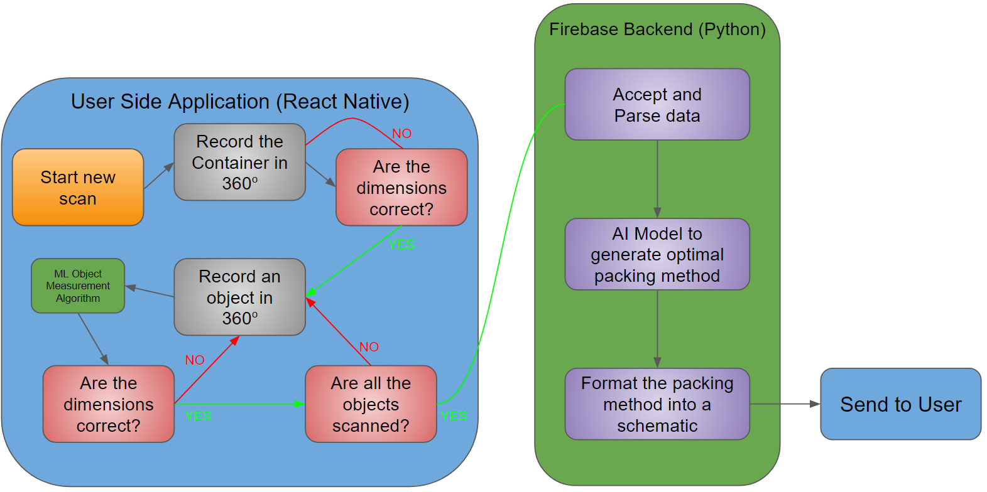

*Fig 1. This image lays out the general framework for the application from the user-side application to back-end processes*

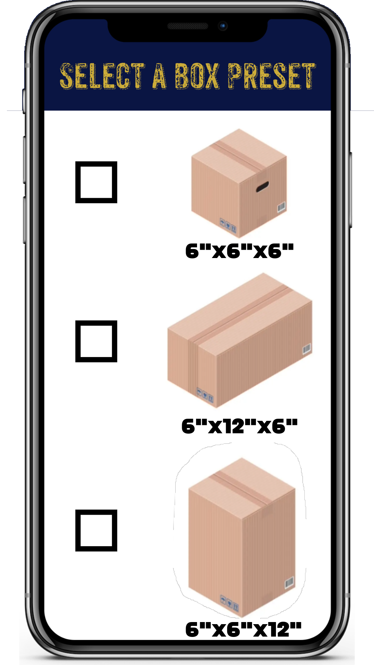 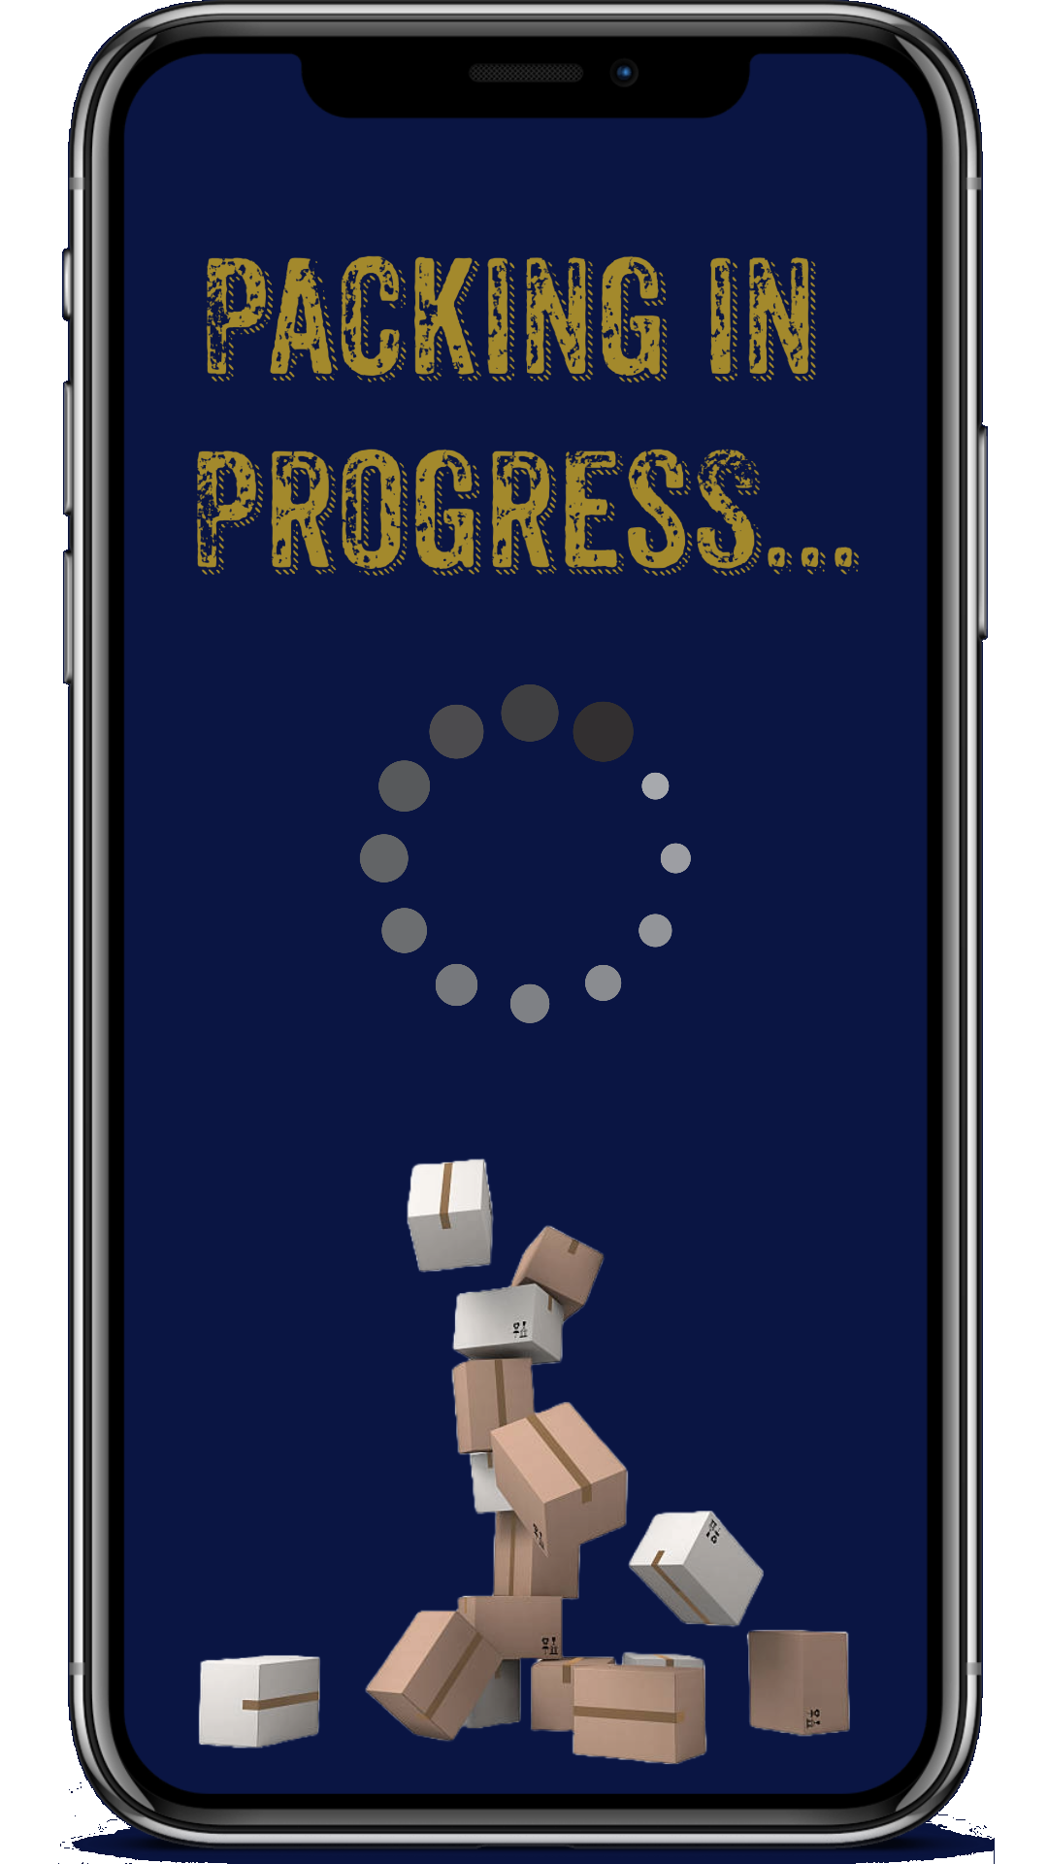

*Fig 2. A preview of some possible application screens on a user device (Selecting predefined container sizes, Loading screens)*

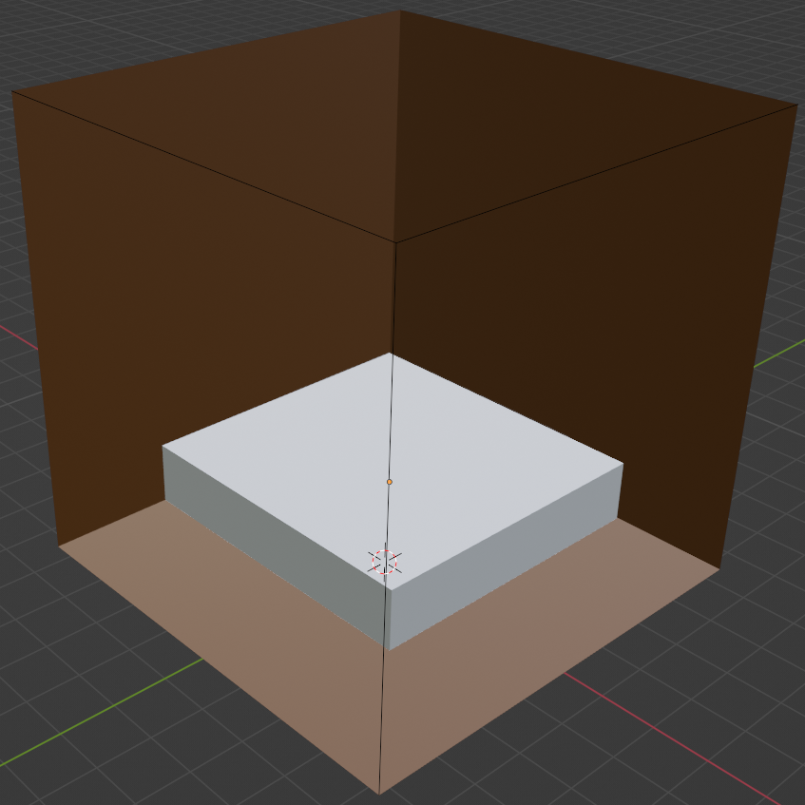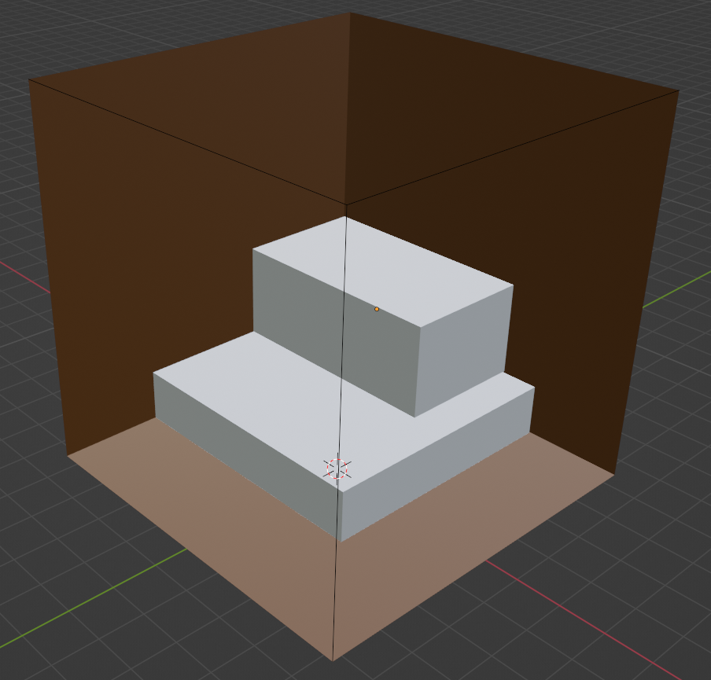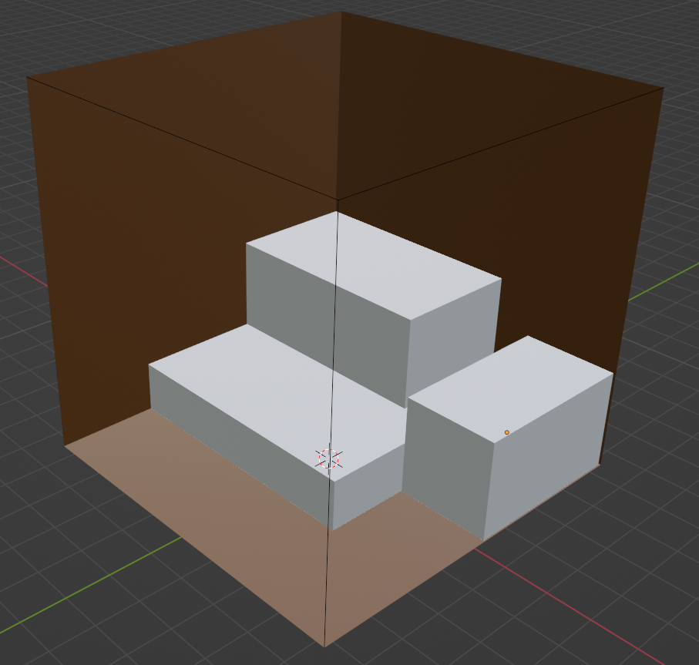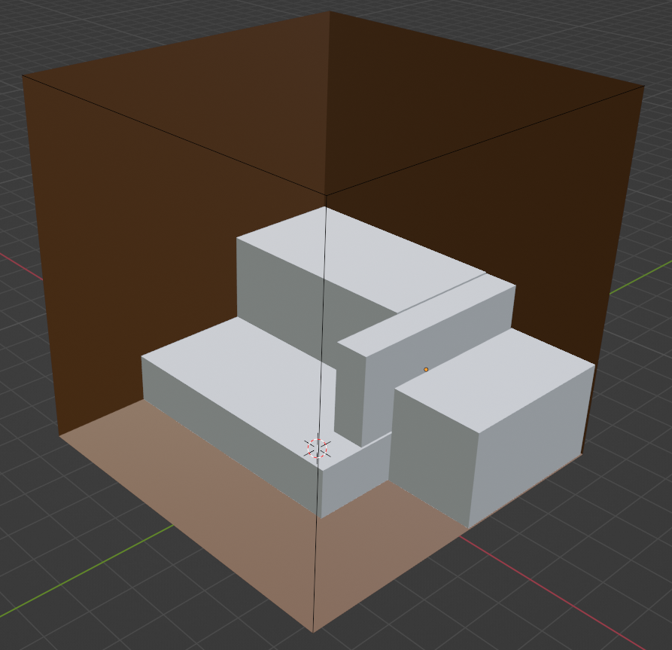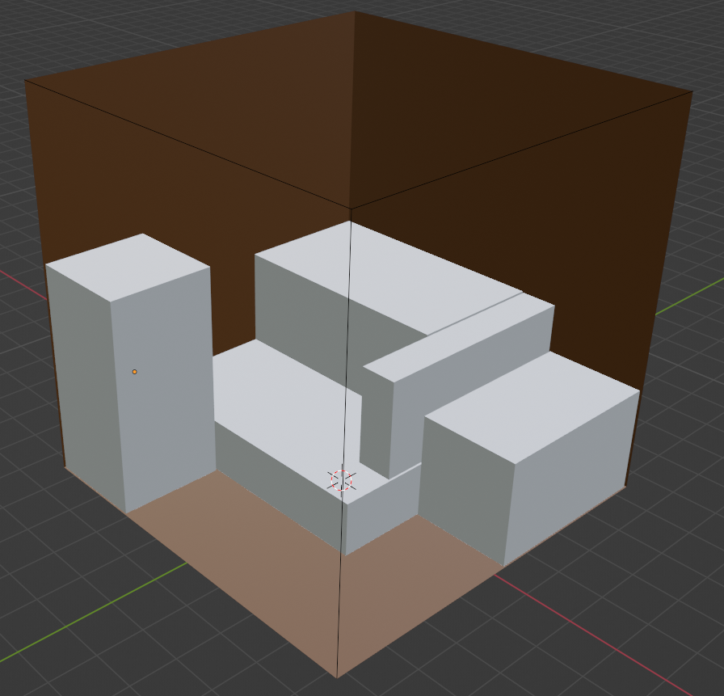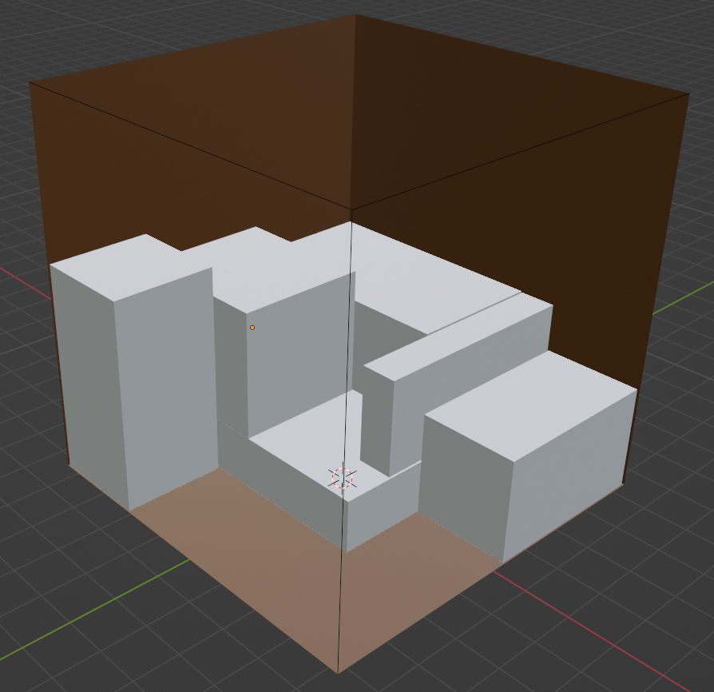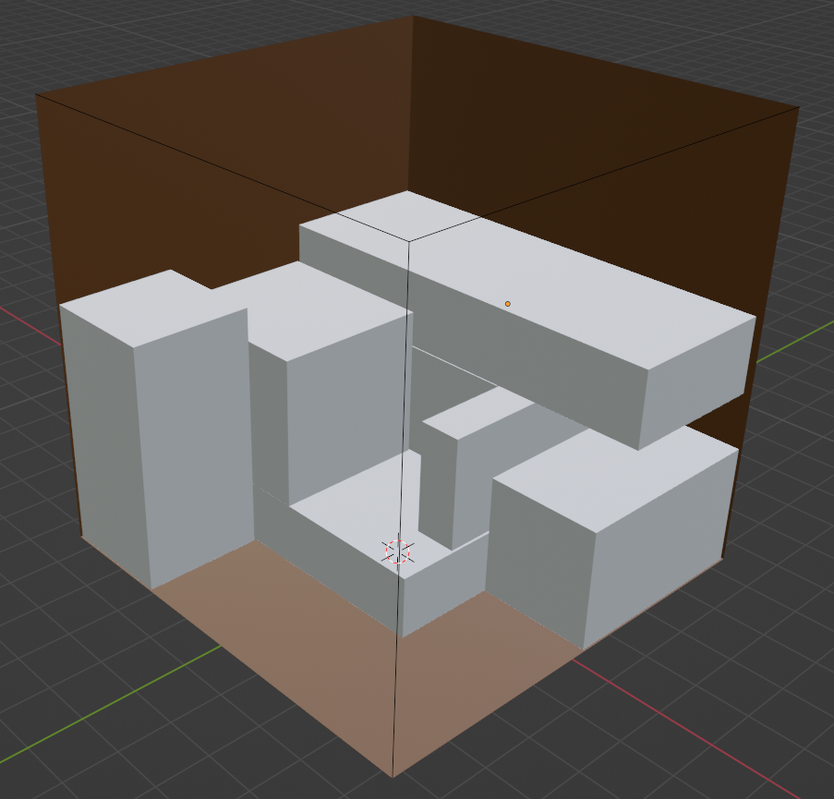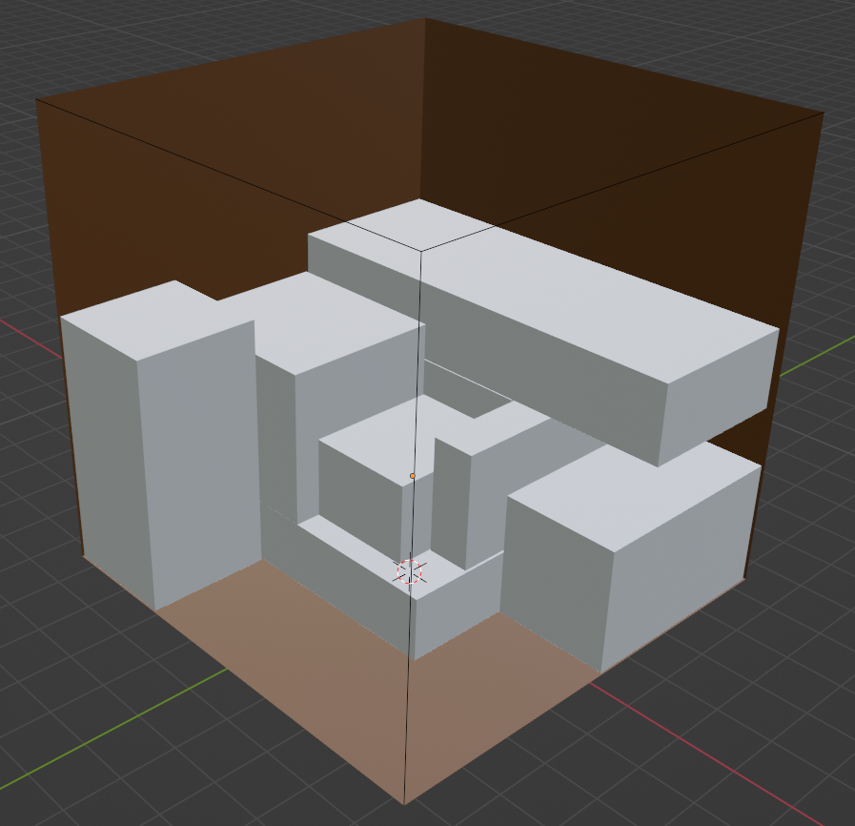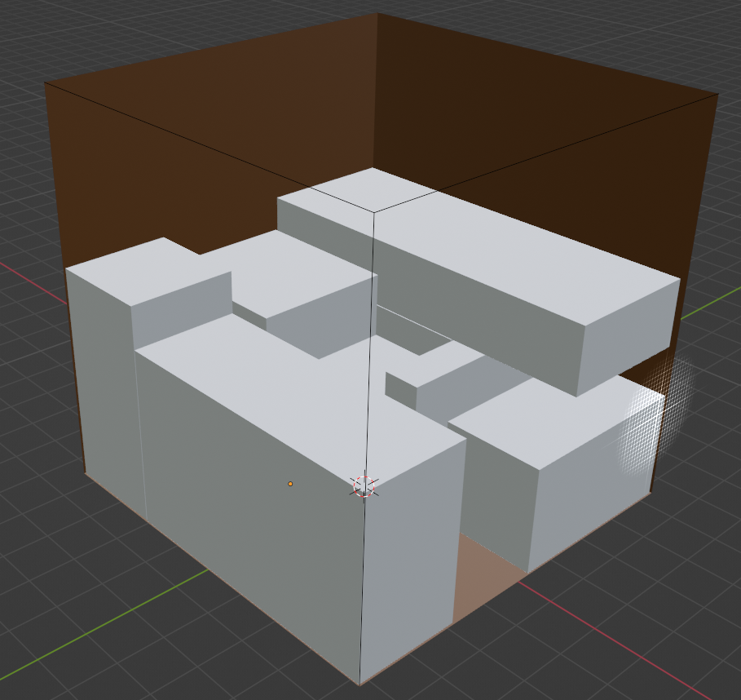

*Fig 3. A basic blender model demonstrating a packing schematic that could be sent to the user*

# 4 Competing technologies

The domain of 3D scanning has unfurled over the years, transitioning from specialized software tools to the recent integration of Artificial Intelligence (AI) and mobile applications. Initially, software tools like Meshroom were employed to aid companies like Activision in accelerating 3D game development through the digitization of real-world objects.

However, the advent of AI has catalyzed a paradigm shift, making 3D object creation accessible right from the smartphone's camera. This technological stride lowered entry barriers significantly, beckoning a plethora of companies to venture into this domain. A notable example is Polycam3D, a mobile application that facilitates 3D object creation from images, enabling the export of 3D object files and the crafting of 3D floor plan environments.

Following suit, other enterprises like the creators of Canvas (formerly known as Pocket 3D Room Scanner) and magicplan have also forayed into this market, offering applications that allow for 3D object creation from pictures. These applications harness the power of AI and the capabilities of modern smartphones to democratize 3D scanning, making it a straightforward task rather than a specialized endeavor.

Despite these advancements, an application encapsulating both 3D object creation capabilities and storage optimization remains to be developed. Such a technology could be a linchpin for conglomerates like Amazon, which could utilize it for optimizing packaging processes.

Furthermore, while the optimization of object positioning in a fixed environment is a resolved challenge, the amalgamation of this solution with 3D object creation and storage optimization has yet to be explored. This uncharted conjunction could potentially unlock new horizons in 3D scanning technology, opening doors to further innovations and solutions in various industries including gaming, real estate, and industrial design.

# 5 Engineering requirements

**5.1 Scanning System**

1. The scanning system must accurately detect object dimensions with an error margin of no more than 5%.

**5.2 Data Collection**

1. The user must be able to use the Camera on their smartphone to scan objects.
2. The user should have the option of scanning each box separately and rescanning if necessary for better accuracy.
3. The ML algorithm must match objects with different sizes and efficiently allocate them in a schematic within a time period of 30s or less.

**5.3 Schematic and Visualization**

1. Pictures of the schematic must have a 3D transparent rotational isometric view or a dynamic stacking of falling boxes to understand the packing process.

**5.4 User Interface and Interaction**

1. The app must have a great UX for the clients to use it in an intuitive way.
2. The system should allow users to save and export packing schematics for future reference or sharing.

# References

1. “Facts and figures about materials, waste and recycling,” United States Environmental Protection Agency, https://www.epa.gov/facts-and-figures-about-materials-waste-and-recycling.
2. g, pp. 227-236, 1989. (Book style with paper title and editor)
3. W.-K. Chen, *Linear Networks and Systems.* Belmont, Calif.: Wadsworth, pp. 123-135, 1993. (Book style)
4. H. Poor, “A Hypertext History of Multiuser Dimensions,” *MUD History,* http://www.ccs.neu.edu/home/pb/mud-history.html. 1986. (URL link *include year)
5. K. Elissa, “An Overview of Decision Theory,"unpublished. (Unpublished manuscript)
6. *Polycam - LIDAR & 3D scanner for iPhone & Android*. Polycam - LiDAR & 3D Scanner for iPhone & Android. (n.d.). https://poly.cam/